**INDEPENDENT UNIVERSITY, BANGLADESH**

**COURSE**: System Analysis and Design

**Submitted by:  
Group: 29  
Ayatullah Arefin - 2022353  
Syed Niaz Mohtasim­-2021607  
Fahim Shahriar-2022523  
Mehedi Hasan Surem-2030069**

**Section:** 02

**SUBMITTED TO:**

Sabrina Alam

**DATE OF SUBMISSION:**

4th December 2022

Contents

Section 1: 3

1. Introduction 3

2. History leading to project request 3

3. Identify Problem, opportunity 4

4. Project goal and objectives 5

Section 2: 6

5. Product Description 6

6. System Context diagram 6

7. Hardware detail (Include Rich Picture) 7

8. Key Technical Features of Software 8

Section 3: 9

9. Information Gathering methods 9

10. Major functionalities offered by the system 11

11. Use Case Diagram 11

12. Normal Scenarios 12

13. Alternate Scenarios 14

14. Functional Requirements 15

15. Non-Functional Requirements 16

Section 4: 17

16. Entity Relationship Diagram 17

17. Logical Data Flow diagram 18

18. Physical Data Flow diagram 18

19. Activity diagrams 19

20. Sequence diagrams 20

21. Communication diagrams 21

22. Class diagrams 22

23. State-chart diagrams 23

24. CRUD matrix 23

Section 5: 24

25. Structure English pseudo code for the system 24

26. Prototype the user interface 25

# Section 1:

### 1. Introduction

**Project Topic:**

Our project name is “**AlumnIUB**”.

“**AlumnIUB**” is a social networking application whose main focus is to connect with all the Alumni of IUB, Connect with all of the IUBian fellows to teach them about career prospects, share about their accomplishments, learn about IUB initiatives, and donate to a good cause.

### 2. History leading to project request

In general, Universities are not practicing what they teach when it comes to their former customers- their alumni. In short, they are failing in alumni engagement. We know about the importance of alumni engagement for alumni relations offices at colleges, universities, and other institutions around the country and across the world. The idea and act of alumni engagement is important because there are alumni organizations of all kinds that want to serve their members better in this particular area. According to a recent study done by Marketing General Incorporated, 87% of alumni professionals shared they need to improve upon engaging their members. Attracting and engaging young alumni is a vital piece of this puzzle.

Independent University, Bangladesh (IUB) is the leading private university in Bangladesh with an explicit focus on research and global partnerships. With a current enrollment of around 10,000 at undergraduate and graduate levels, more than 450 highly-qualified faculty members, 47% of whom have PhD degrees, and an alumni strength of close to 14,000, But for these alumni there is no any engagement site where they can connect or find each other.

This is where " **AlumnIUB** " seeks to make a difference by linking Alumni with other Alumni, Students and University. Users can seek for help and connect with other alumni also can share their experience on that application.

### 3. Identify Problem, opportunity

**Project Analysis:**

|  |  |
| --- | --- |
| **Problem** | **Solution** |
| New graduates are struggling in their new work environment and require mentors or sound advice. They could feel disoriented if they don't have this mentorship. | The app solves this problem by allowing users to connect with other alumni, which allows them to learn about their experiences and ask questions so that other alumni who have faced the same issue in the past may help them by providing feedback. |
| There is no valid data for analytics about Alumni. Data need to be stored in a way to find easily. | With this app Users can build customized and significant alumni experiences at scale using data analytics, sophisticated segmentation, and marketing automation. |
| It is a hard task for the university to track all the alumni’s Information and Invite them for events and seminar sometimes | All data of users are kept in a database. Hence, inviting them for events and seminar will be easy using this app. |

This social networking application can open wide range of opportunities in the future as we would be able to analysis the data and work on new features as well as make necessary changes if needed. Some of the opportunities are listed below:

* We can also enable new options for the people to use this app for other Universities.
* Maintaining an active alumni community has several benefits, including fundraising. by this app we can raise money for issues that are advantageous to the university.
* This may be advantageous for both universities and former students since it establishes a network of people who can get in touch with, assist, or work together on commercial endeavors.
* Having a large, active alumni network may be a great tool for building brand recognition for your university and aiding in the recruitment of the best students.
* Alumni from different University can meet, connect, interact and make networks by this friendly community created in this app.
* The government and other organizations can build or improve any country problems with the help of all the experienced and talented Alumni by analyzing data from this application.
* Companies of alumni can market their products and services by partnering with the app developers.
* Users can give feedback which can help improve the system.

### 4. Project goal and objectives

The main goal of this project is to develop a social networking platform only for IUB’ students and alumni. The application will also aim to effectively reduce the problem of not finding their course mates and friends information. University authorities arranging any event and that time they can find all the information or give all the information on this application. An active and connected alumni network benefits both universities and former students. Understanding that the student experience doesn't end with graduation is crucial when considering the wider picture of alumni involvement.

The objective of this networking application project is to design and build a mobile application to help students and University to connect with all the alumni who graduated from IUB or going to graduate from IUB. The long-term viability of any university depends on alumni participation.

The goals and objectives of my project are listed below,

* To create a database to store information about students who already graduated from IUB.
* To store information of their other social media information of Facebook, Email and LinkedIn to connect.
* To share their achievements.
* If new graduates need any help regards finding new jobs, then they can ask for mentorship from their Alumni.
* For the information database University can invite Alumni of IUB for any events and seminars so that they can share their experience with all the new students.
* To Donate for social cause, Charity, Raising Money for any individuals or fellow IUBians with Health Conditions.

# Section 2:

### 5. Product Description

Institutions have a lot of options to invest in this app. Since a mature university will have thousands of alumni, a strong network may be one of the most effective instruments for universities to continue growing and enhancing the educational experience of current students. The connections with students, both past and present, will be improved with the help of that effective alumni engagement plan. Building a strong alumni network in IUB is made much easier and more controllable by using a platform like **AlumnIUB**.

**System Stakeholders:**

* University
* Students
* Former students (Alumni)
* Faculty Members
* System Engineers
* Mobile Application Administrators

### 6. System Context diagram

**Context Level Data Flow Diagram:**

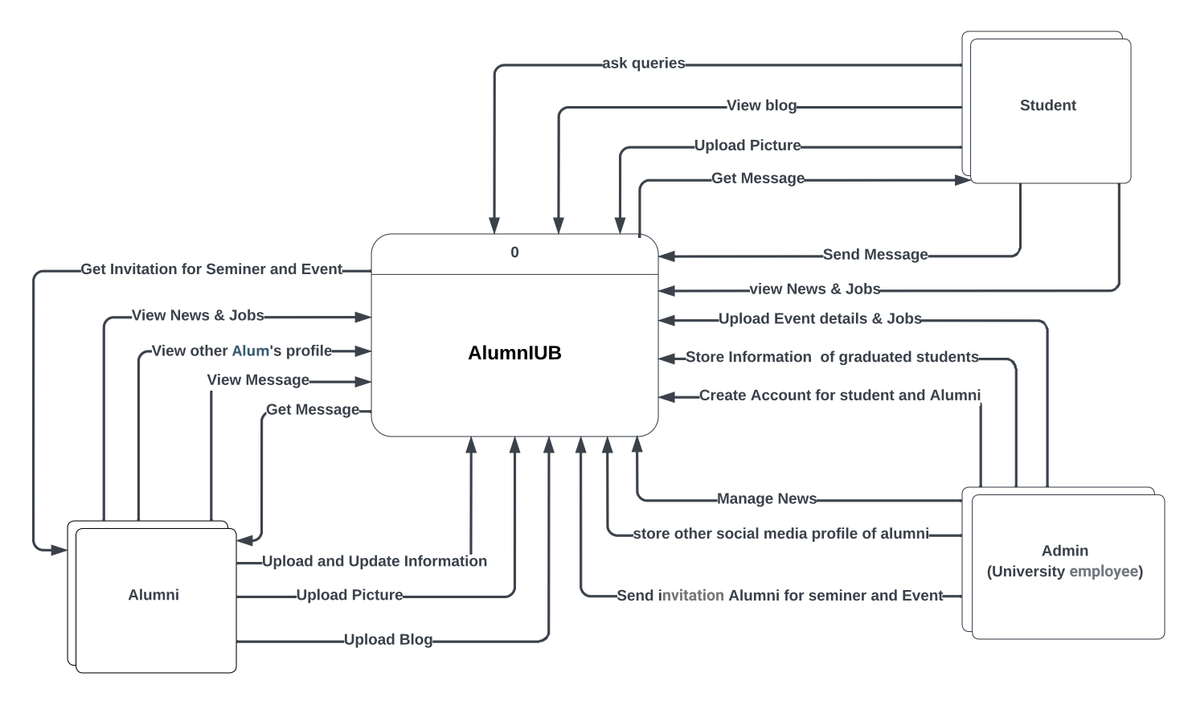

### 7. Hardware detail (Include Rich Picture)

**Rich Picture:**

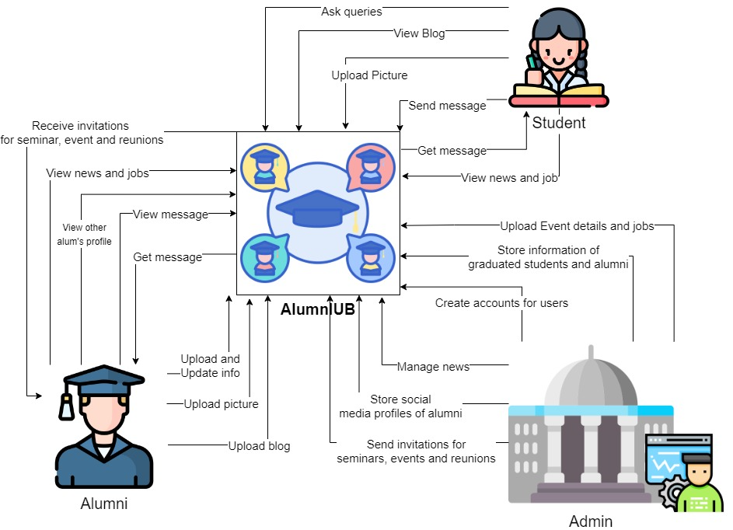

**Development Environment:**

* The minimum hardware requirement of implement the system would be an intel dual core processor or a AMD Ryzen dual core processor with at least 2GB RAM, 120GB hard disk and other standard hardware
* The software’s required in the process would be VS code, MySQL server and any desktop operating system

**Operating Environment:**

* The hardware of the operating device should be such that it must be capable of running a mobile application.
* Any working smart phone an android operating system (minimum version – android KitKat 4.4.4) or IOS (minimum version iOS 8) or any Linux based operating system

### 8. Key Technical Features of Software

* The mobile application can be accessed from anywhere, anytime with any modern smartphone android, iOS or Linux based operating system.
* The mobile application offers increased data security and ensures data integrity by RDBMS
* As per one’s need various customization can be done. For example- changing theme to dark mode.

# Section 3:

### 9. Information Gathering methods

Data collection is essential for developing software that fulfills its goals. We won't be able to meet the needs of the software's users if we don't take into account their recommendations and viewpoints. For my system, I've selected three primary information collection methods: stories, interviews, and Feasibility Analysis.

1. Stories

Story 1

One day We were talking with one of our seniors Tahmid Ahmed from IUB who graduated in 2010. He lives in the USA now. So, in that conversation he told us he is searching for one of his classmates who graduated with him but after the graduation he could not find his information. It could have been easier if IUB had a system where he might find his classmate’s social media account like Facebook or LinkedIn. He also added that he doesn’t get any news regarding any events that IUB arranges because of his busy working life. He misses his university life. He sometimes wants to know all the great things happening in IUB.

Findings from the story

* There is demand for a better alternative social networking application for IUB.
* Former Students want a reliable site to get information from university.

Story 2

Hello, I am Ayatullah Arefin, this story is from my side. I was working for a departmental club. So, our department told us to search Facebook and LinkedIn profile of our university alumni by checking their name from an excel sheet and put the link of their profiles in that excel sheet again which was too confusing for us that time. But if we start a system where students sign up for the account and they can also update their profiles and add links of their other main social media accounts. These accounts will be created by IUB authority and also permanent for every IUB students and alumni. Which will be Easier for everyone.

Findings from the story

* There is a need to create a database to store information about students who already graduated and existing students from IUB.

1. Interviewing

To better comprehend the situation, I decided to meet with the stakeholders. Conducting interviews is a vital step in getting the data and information needed to meet the requirements. Information on a wide range of important topics is provided via interviews. Justifications for goals, important Human Computer Interactions, feelings, and opinions are only a few examples (HCI). I explained the operation of my smartphone app "AlumnIUB" to them at the start of our conversation. Selected Interviewees are Students, University Authorities and Admin/ System Developer.

Selected Interviewee: Student

1. Are you okay with the current situation of not having any social networking application for our university?
2. Do you think the proposed system will help to serve your need properly?
3. If the proposed system were available today, would you use it?
4. Do they think the new system will be successful and accepted?
5. If you were in charge of this system, what would you change?
6. How can we improve the system?

Selected Interviewee: University

1. Do you think we need a social networking application for our university alumni?
2. Do you think the proposed system will help to serve everyone’s need properly?
3. Do they think the new system will be successful and accepted?
4. If you were in charge of this system, what would you change?
5. How can we improve the system?

Selected Interviewee: Admin /System Developer:

1. What are the security issues that will cause problem?
2. How often they need to check system?
3. How long will it take to update the system?
4. Can they work in case of emergency?
5. Feasibility Analysis

A feasibility study is a quick analysis that helps management decide whether or not to move on with developing a system study.

* It acknowledges the potential for improving an already-existing system, developing a brand-new system, and producing updated estimates for ongoing system development.
* It is used to formulate the issue and ascertain whether or not a practical or appropriate solution is available.
* Instead, then trying to find a solution, a feasibility study's main objective is to ascertain the problem's size.
* A feasibility study results in a formal system proposal that covers the whole nature.

### 10. Major functionalities offered by the system

* users can connect with other alumni, which allows them to learn about their experiences and ask questions so that other alumni who have faced the same issue in the past may help them by providing feedback.
* Users can build customized and significant alumni experiences at scale using data analytics, sophisticated segmentation, and marketing automation.
* All data of users are kept in a database. Hence, Admin can invite them for events and seminar easily using this app.

### 11. Use Case Diagram

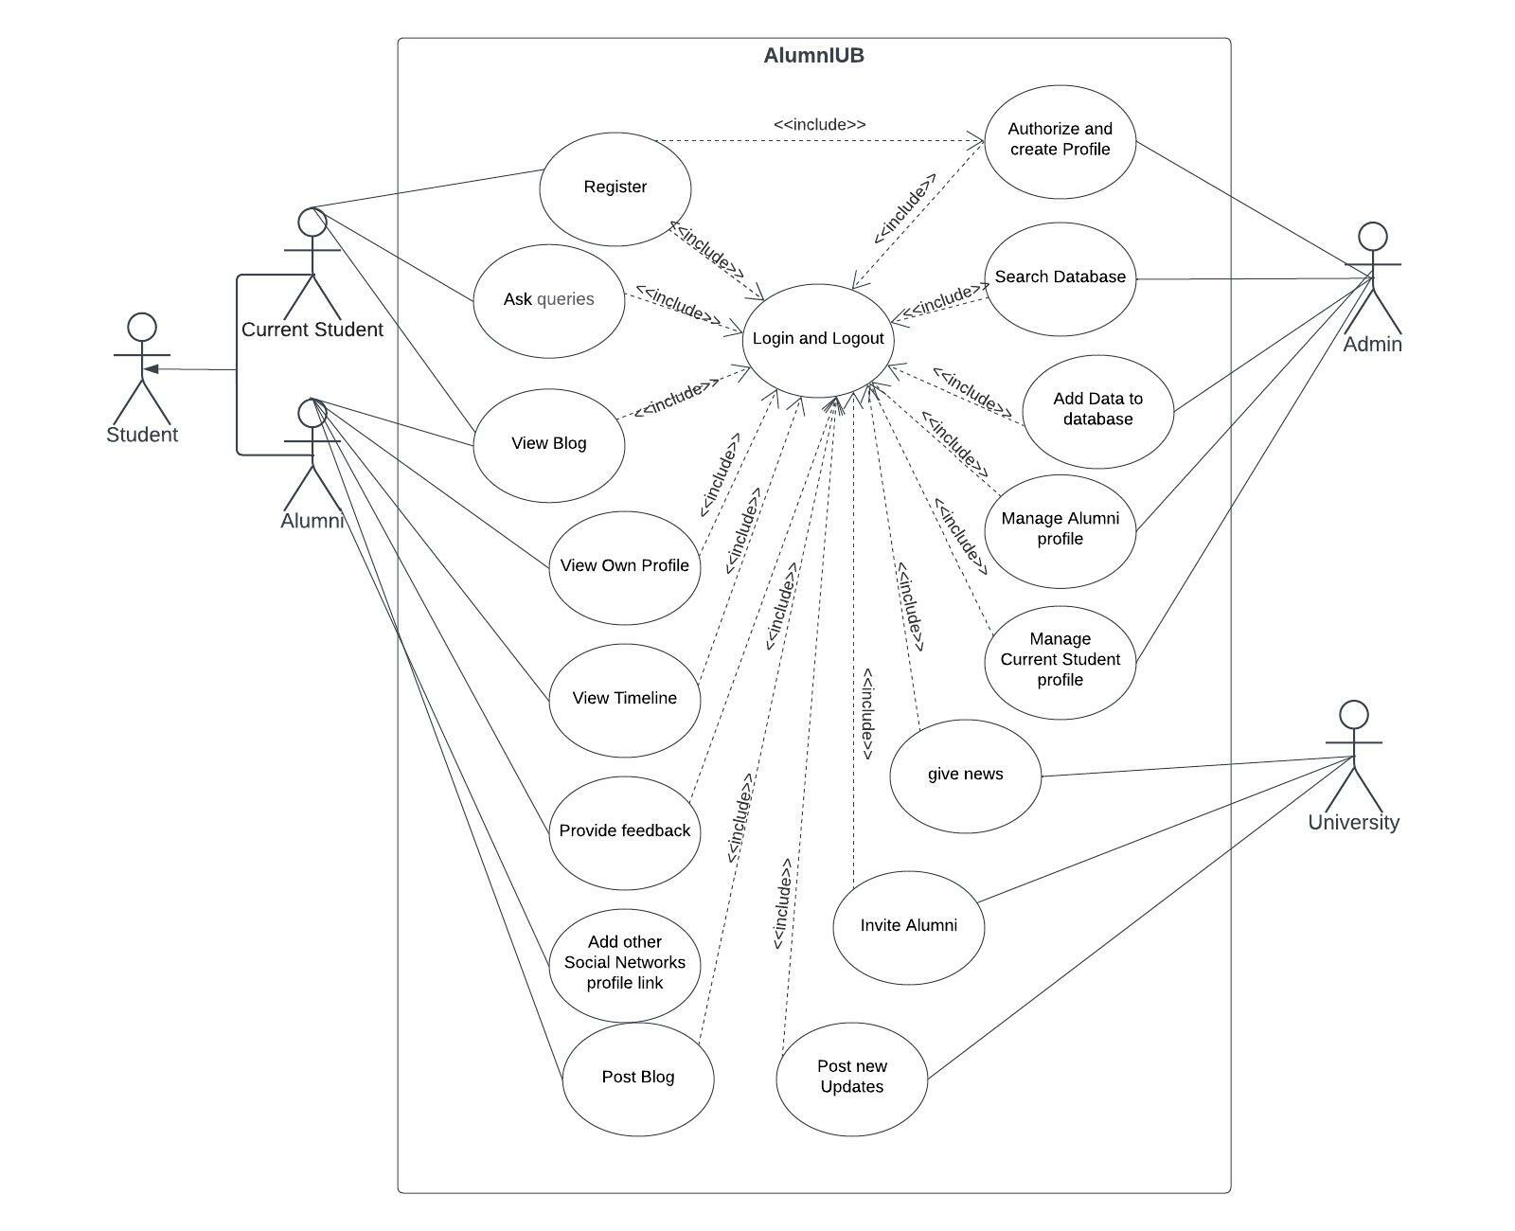

### 12. Normal Scenarios

**Scenario 1:**

|  |  |
| --- | --- |
| Use Case Name: Register For AlumnIUB Unique ID: KA-00001 | |
| Actor(s): Student | |
| Stakeholders: University, Student. | |
| Description: User registers in the mobile app as Student or Alumni | |
| Triggering Event: User registers in the app and inputs information. | |
| Trigger type: External | |
| Steps Performed: | Information Required for Steps: |
| 1. The registration interface loads. |  |
| 2. Selects user type. | user wants to register as Student or Alumni |
| 3. User enters the following  information:  Email, User type, username, Student ID, Major, Admission Year, NID card number, Mobile Number, address, password etc. | Personal information of user like User type,  username, NID card number, Mobile  Number, Student ID, email, password. |
| 4. Clicks the submit button. | All required information must be filled up. |
| 5. If all information is correct then user  will be registered to the system. |  |
| 6. A unique id will be given to the user  and a confirmation message will be  shown to the user interface. | Unique id and a confirmation message |
| Pre-condition: User needs to have idea about the features of the app. | |
| Post-condition: User must carefully input all required information while registering. | |
| Assumption: User wants to use the app | |

**Scenario 2:**

|  |  |
| --- | --- |
| Use Case Name: Post Blog Unique ID: KA-00002 | |
| Actor(s): Alumni | |
| Stakeholders: Alumni, Admin, Student | |
| Description: Post Blog using the mobile application | |
| Triggering Event: After posting blog user will be able to see comments and react of other users | |
| Trigger type: External | |
| Steps Performed: | Information Required for Steps: |
| 1. User logs in to the system. |  |
| 2. Clicks in a box name create a blog. There will be a prompt written “What do you want to talk about?” | user must be registered in the app. |
| 3. Fills up the box with user’s thoughts or speech, career advice | Present date of the blog |
| 4. Clicks the “Post” button. | All required information must be filled up. |
| 5. If the blog is well written then the admin of the system will make the post visible for other users |  |
| 6. User can see other’s comment and reacts of that blog |  |
| 7. User can also reply other user’s comment by clicking the button reply and then after writing the reply press send button |  |
| Pre-condition: User needs to be Registered to the app. | |
| Post-condition: User has posted the blog | |
| Assumption: User wants to use the app | |

### 13. Alternate Scenarios

**Scenario 1:**

|  |  |
| --- | --- |
| Use Case Name: Register For AlumnIUB Unique ID: KA-00001 | |
| Actor(s): Student | |
| Stakeholders: University, Student. | |
| Description: User registers in the website as Student or Alumni | |
| Triggering Event: User registers in the app and inputs information. | |
| Trigger type: External | |
| Steps Performed: | Information Required for Steps: |
| 1. The registration interface loads. |  |
| 2. Selects user type. | user wants to register as Student or Alumni |
| 3. User enters the following  information:  Email, User type, username, Student ID, Major, Admission Year, NID card number, Mobile Number, address, password etc. | Personal information of user like User type,  username, NID card number, Mobile  Number, Student ID, email, password. |
| 5. If any information is not correct then  an error message will be shown that  information is not valid and which  information is invalid is also shown. Then  prompted to enter valid information. | Error message, invalid information |
| 4. Clicks the submit button. | All required information must be filled up. |
| 5. If all information is correct then user  will be registered to the system. |  |
| 6. A unique id will be given to the user  and a confirmation message will be  shown to the user interface. | Unique id and a confirmation message |
| Pre-condition: User needs to have an idea of how the mobile application works. | |
| Post-condition: User must carefully input all required information while registering. | |
| Assumption: User wants to use the app | |

**Scenario 2:**

|  |  |
| --- | --- |
| Use Case Name: Ask Queries Unique ID: KA-00002 | |
| Actor(s): Alumni, Student | |
| Stakeholders: Alumni, Admin, Student | |
| Description: Post Blog using the mobile application | |
| Triggering Event: After posting Queries user will be able to see comments and react of other users | |
| Trigger type: External | |
| Steps Performed: | Information Required for Steps: |
| 1. User logs in to the system. |  |
| 2. Clicks in a box name Add Question. There will be a prompt written “What do you want to talk about?” | user must be registered in the app. |
| 3. Fills up the box with user’s thoughts or Question | Present date of the blog |
| 4. Clicks the “Post” button. | All required information must be filled up. |
| 5. If the Query is valid then the admin of the system will make the post visible for other users |  |
| 6. User can see other’s comment and reacts of that blog |  |
| 7. User can also reply other user’s comment by clicking the button reply and then after writing the reply press send button |  |
| Pre-condition: User needs to be Registered to the app. | |
| Post-condition: User has posted the blog | |
| Assumption: User wants to use the app | |

### 14. Functional Requirements

It's critical to under what the functional requirements of a system are

for both the development team and the stakeholders. The functional

requirements of the system are as follows:

1. Users will be able to use the app on a variety of mobile devices

include Windows, Android, IOS and Linux.

2. Users will have the option of registering as a Student or a Alumni.

3. The user interfaces for Student and Alumni will be distinct.

4. The user will be able to specify their preferences to achieve a better

result.

5. The user will be able to both input and select the data that is

required.

6. The app database will hold all the data.

7. All saved data will be safe and secure and will not be tampered with.

8. For each registered user, a user profile will be created.

9. User will be allowed to edit profile anytime.

10. The information that the user has altered will be automatically

updated and saved.

14. All user data will be encrypted for data security.

15. During registration, users' identities will be verified by email, phone

number and NID verification.

16. The user will receive a verification code by email or phone call.

17. The user will be able to reset their password by submitting a request.

19. Users will have the ability to rate and comment on the application.

20. Any user criticism will be forwarded to the admin authority

### 15. Non-Functional Requirements

The non-functional requirements of the system are as follows:

**Reliability:**

* The system must be always available and should not experience any downtime.
* All tasks must be completed without any software-related errors or with minimal errors.

**Performance:**

* It should return a search result in 2/3 seconds.
* The user interface must be visible in less than five seconds.

**Maintainability:**

* All this system's data must be maintained safe no matter what happens to it; hence the system will require data backup planning.
* If an error happens during any of the system's processes, the system will be able to trace each fault and correct it as quickly as possible before continuing the operation.

**Efficiency:**

* The system must be able to accommodate at least 1,000 individuals at the same time while also consuming minimal resources such as memory, CPU, and disk space.

**Security:**

* To utilize this system, users must first register, after which only registered users can access the system's features by logging in with their ID and password.
* Ascertain that the system, or any of its data, is never subjected to malware attacks or illegal access.
* Unless it is required, a user's personal information or other data should not be available to other users.

**Scalability:**

* This system must be scalable because it will be used by anyone admitted to IUB. Number of students in IUB increases every semester. That is, regardless of how much memory, servers, or disk space is required, the system should be able to accommodate an increase in the number of users and processes without affecting performance.

# Section 4:

### 16. Entity Relationship Diagram

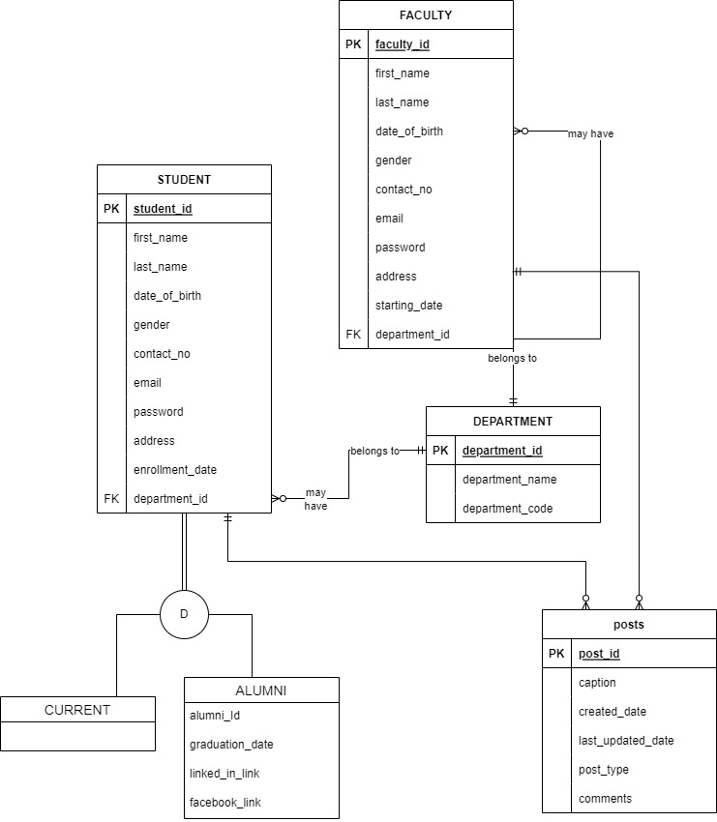

### 17. Logical Data Flow diagram

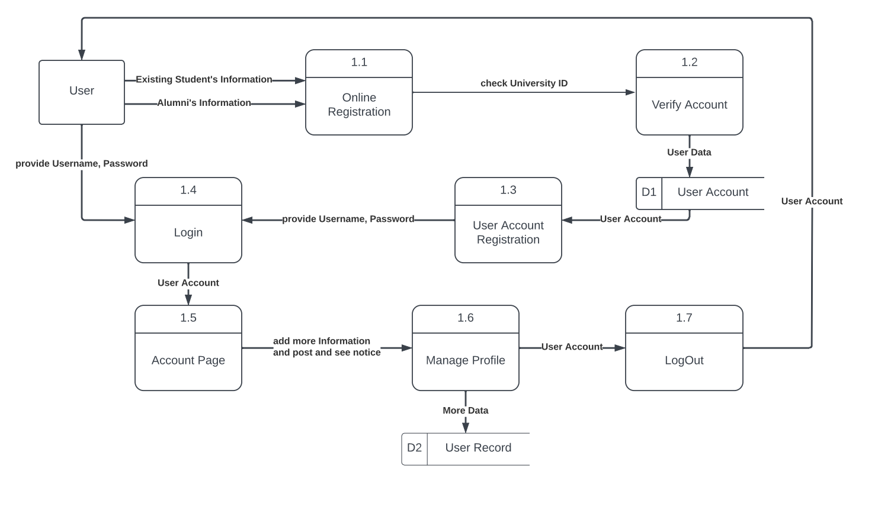

### 18. Physical Data Flow diagram

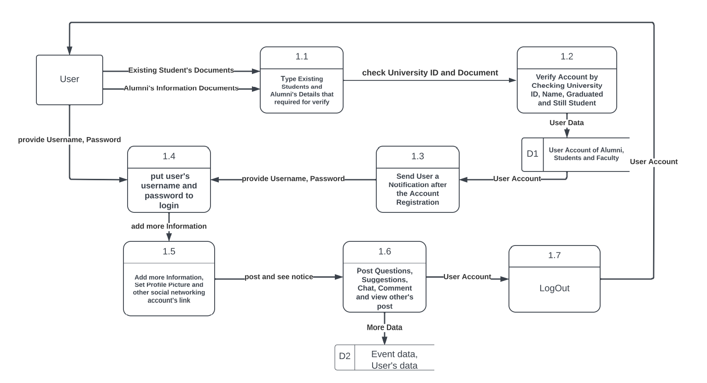

### 19. Activity diagrams

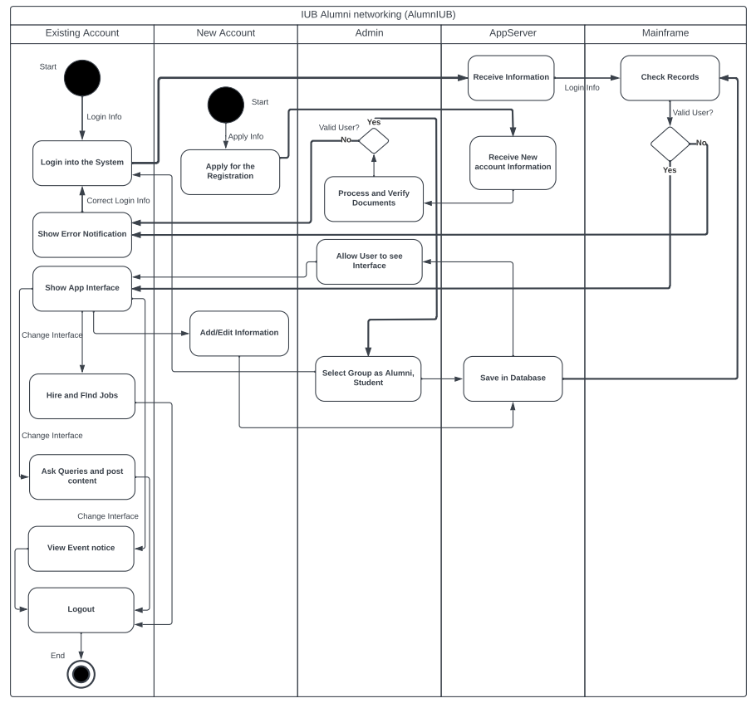

### 20. Sequence diagrams

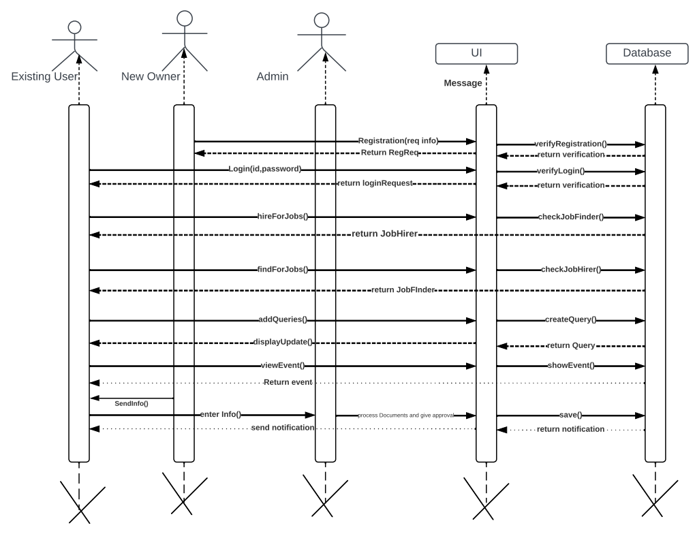

### 21. Communication diagrams

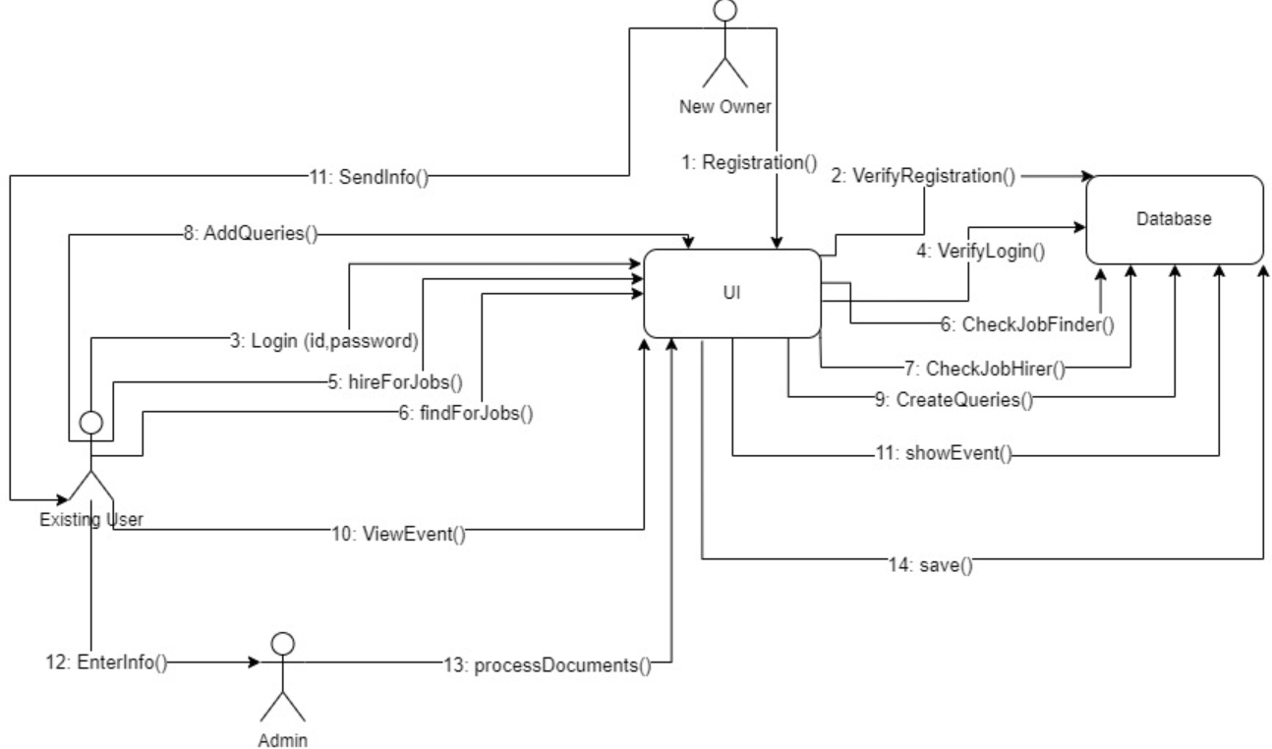

### 22. Class diagrams

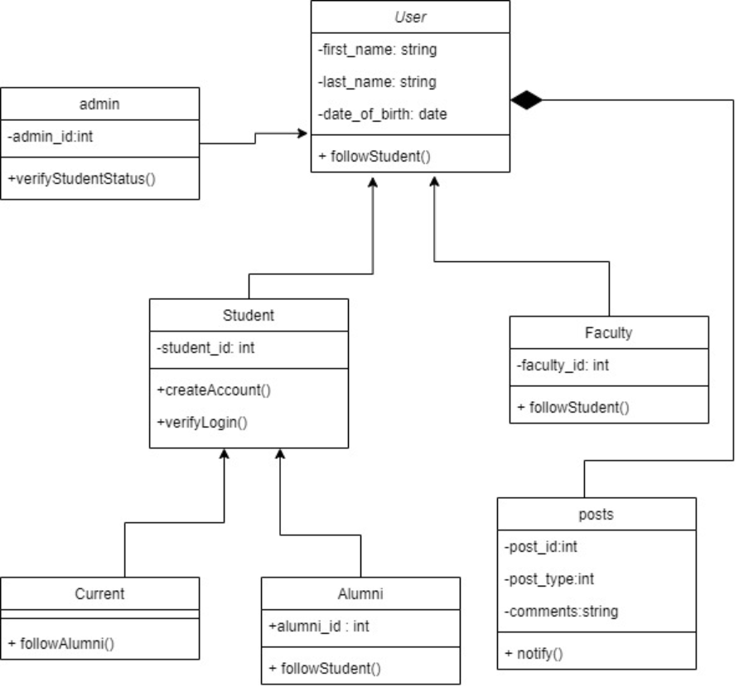

### 23. State-chart diagrams

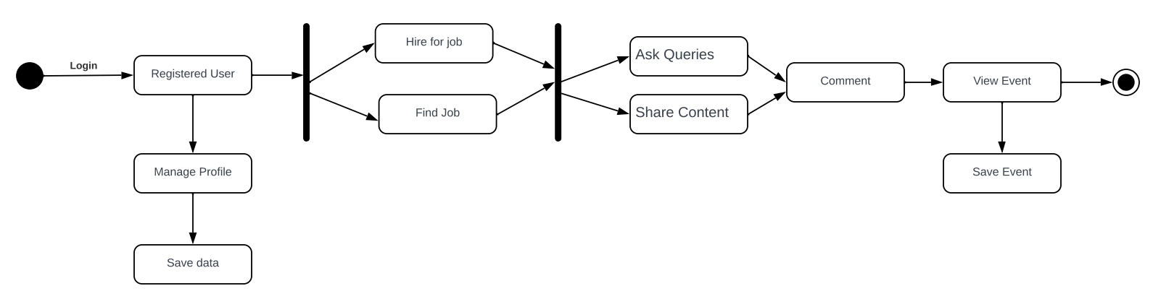

### 24. CRUD matrix

|  |  |  |  |  |
| --- | --- | --- | --- | --- |
| Activity | Student | Alumni | Faculty | Admin |
| Register | C | C | C |  |
| Login | R | R | R |  |
| Connect / Follow | R | R | R |  |
| Post job postings | R | CRUD | CRUD | UD |
| Invite to events | R | R | R | CUD |

# Section 5:

### 25. Structure English pseudo code for the system

IF “Sign Up” clicked THEN  
 GET registration form  
 DISPLAY form  
 FILLUP credentials  
 CLICK “Create Account”

ELSE “Login” clicked THEN  
 GET login interface  
 DISPLAY interface  
 FILLUP credentials  
 CLICK “Login now”

DO WHILE user logged in  
 IF “Job” clicked THEN  
 GET job interface  
 DISPLAY interface  
 IF “Find” clicked THEN  
 GET find interface  
 DISPLAY interface  
 ELSE “Hire” clicked THEN  
 GET hire interface  
 DISPLAY interface  
 ELSE IF “Forum” clicked THEN  
 GET forum interface  
 DISPLAY interface  
 IF text-field filled THEN   
 CLICK “Share”  
 ELSE IF “Event” clicked THEN  
 GET event interface  
 DISPLAY interface  
 ELSE IF “Find people” clicked THEN  
 GET find people interface  
 DISPLAY interface  
 IF searchbar filled THEN   
 CLICK “Search”  
 ELSE IF “My Profile” clicked THEN  
 GET my profile interface  
 DISPLAY form  
 IF credential filled up THEN  
 CLICK “Save Profile”  
 ELSE “Logout” clicked THEN  
 application CLOSED

### 26. Prototype the user interface

First Interface

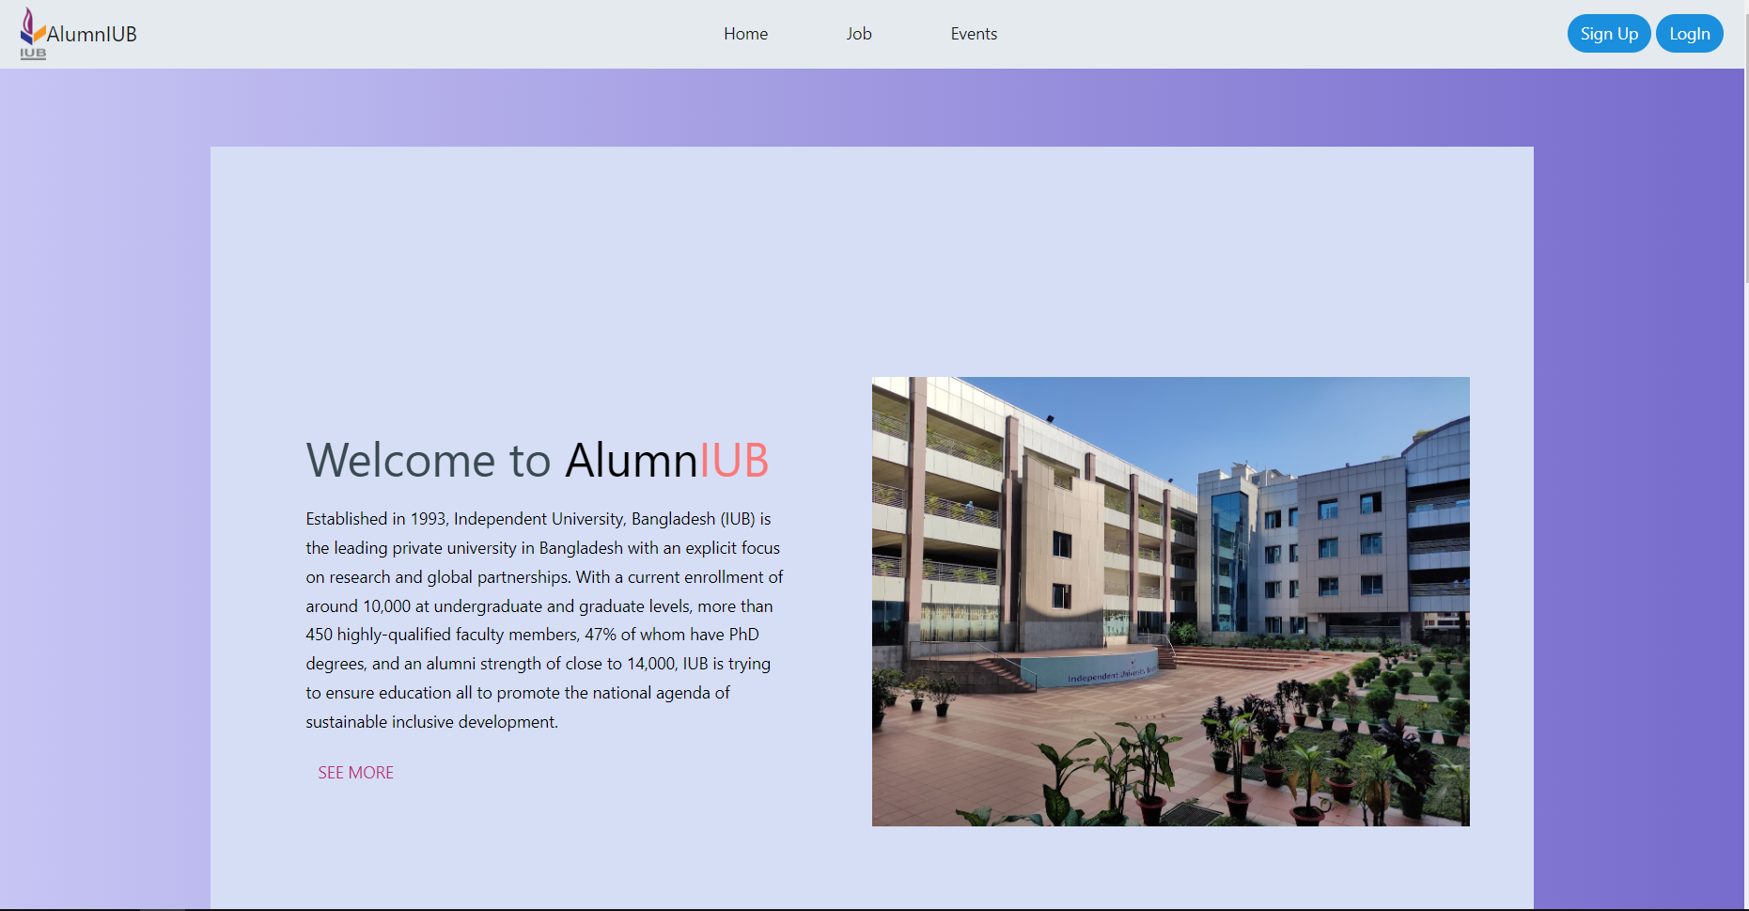

Sign Up Interface

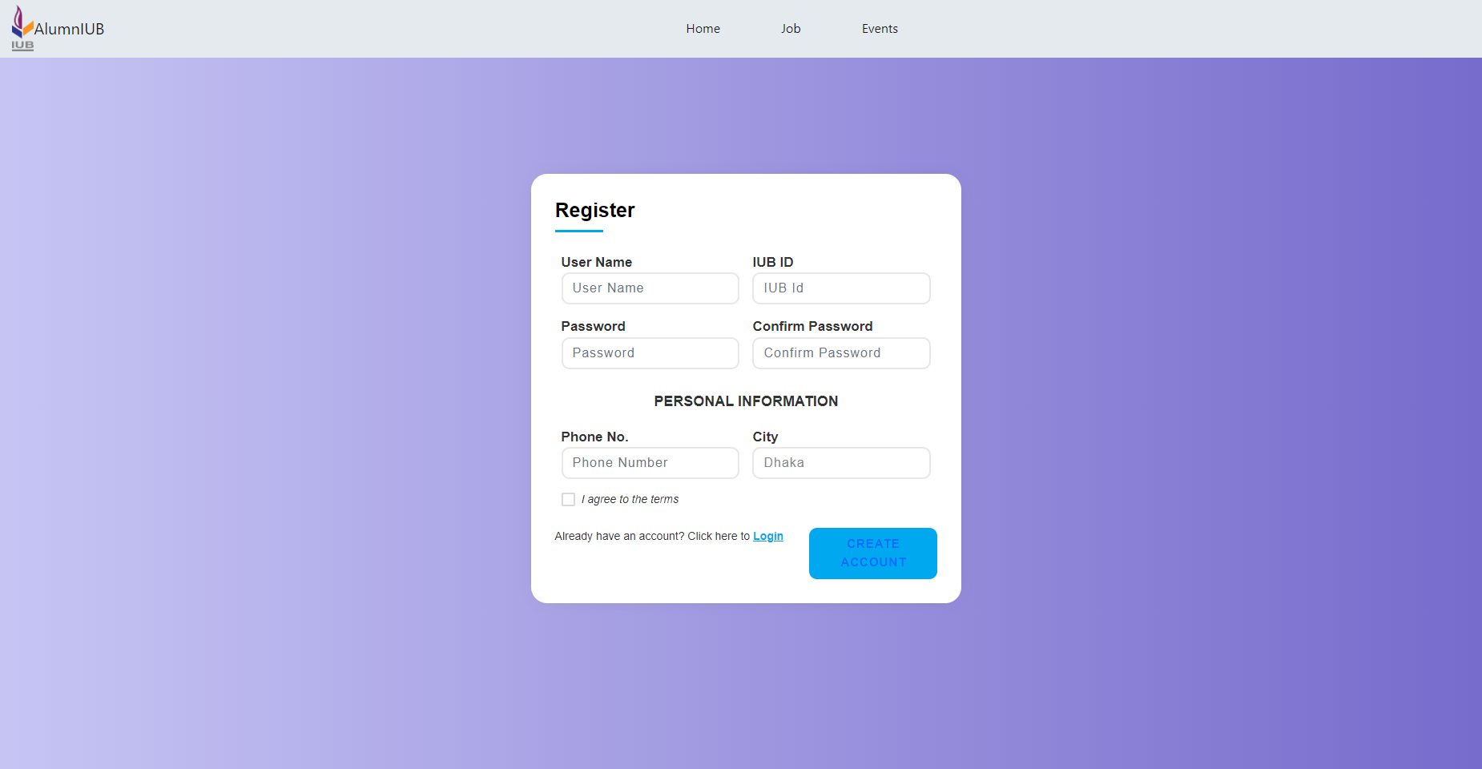

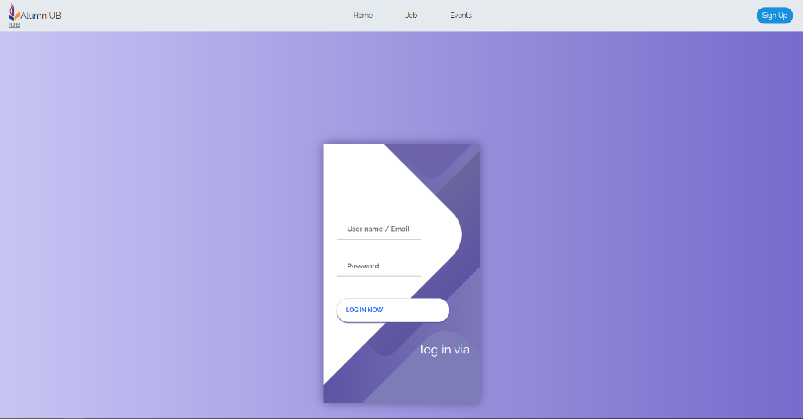Login Interface

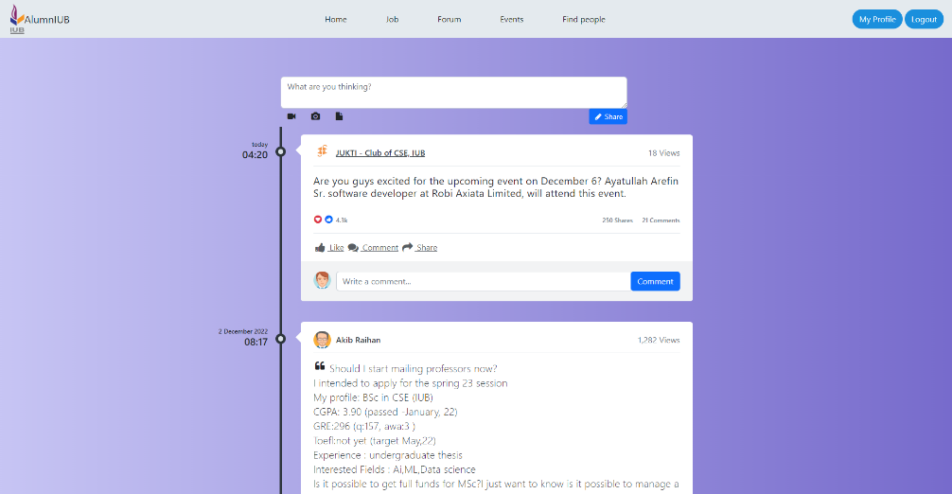Forum Interface

Event Interface

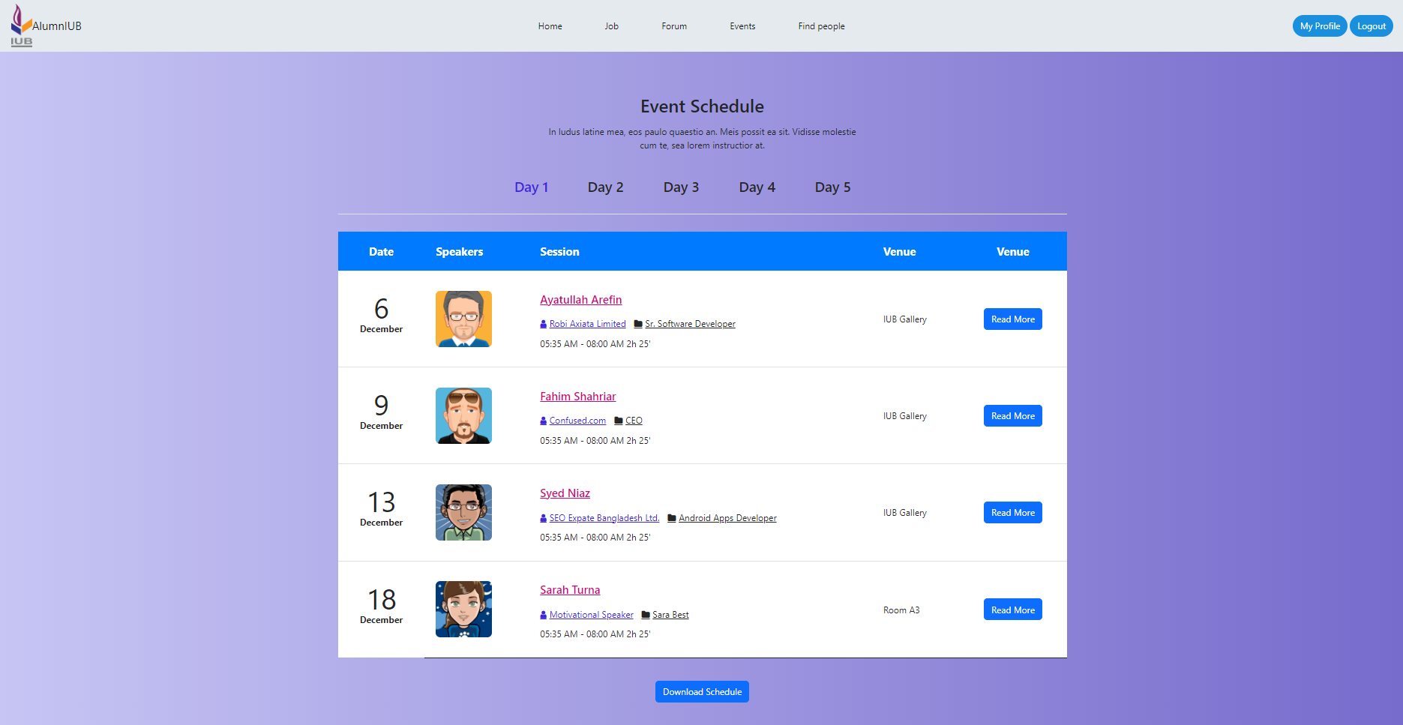

Find People Interface

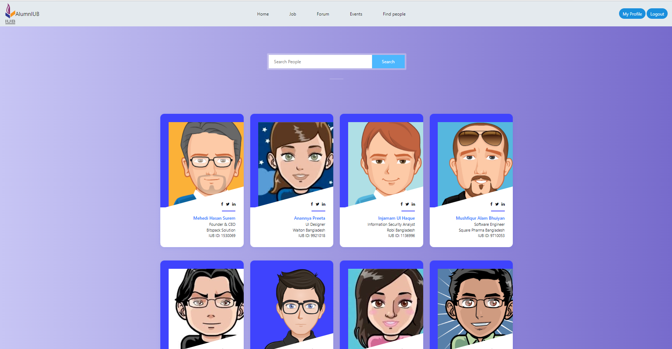

Jobs Interface

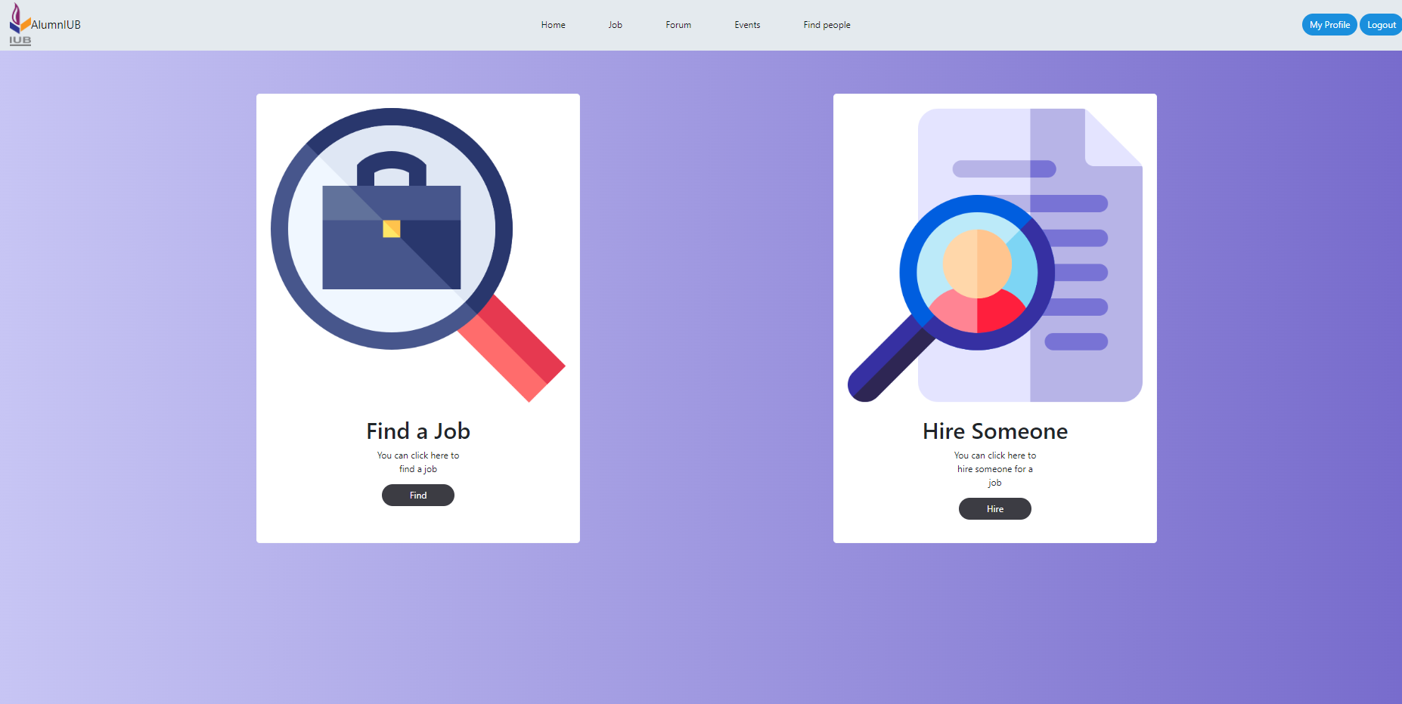

Find A Job Interface

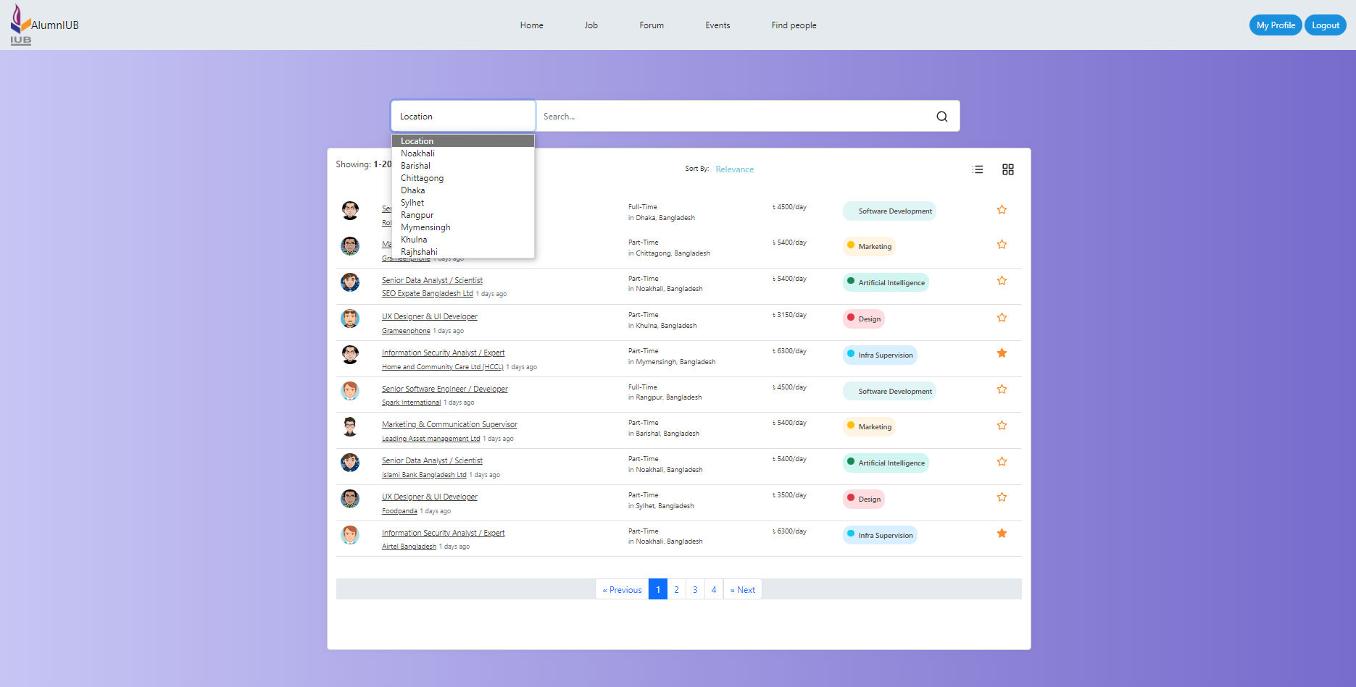

Hire Someone Interface

Section-01

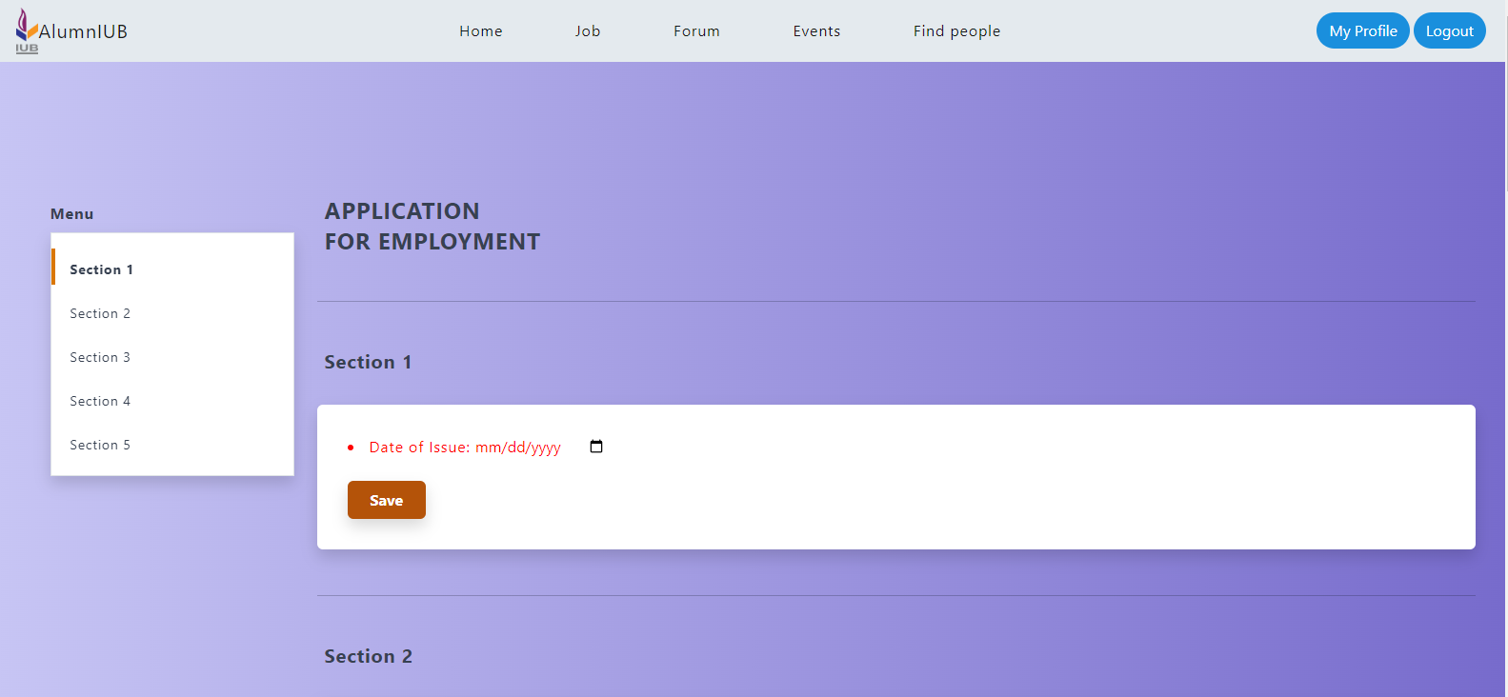

Section-02

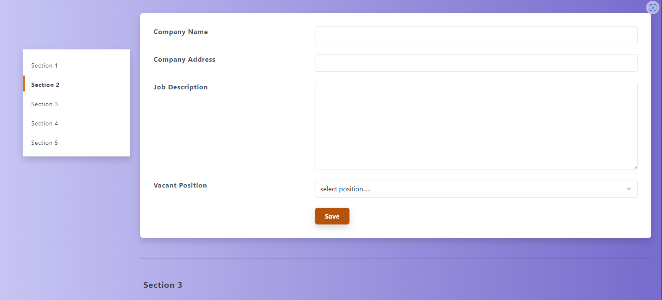

Section-03 and 04

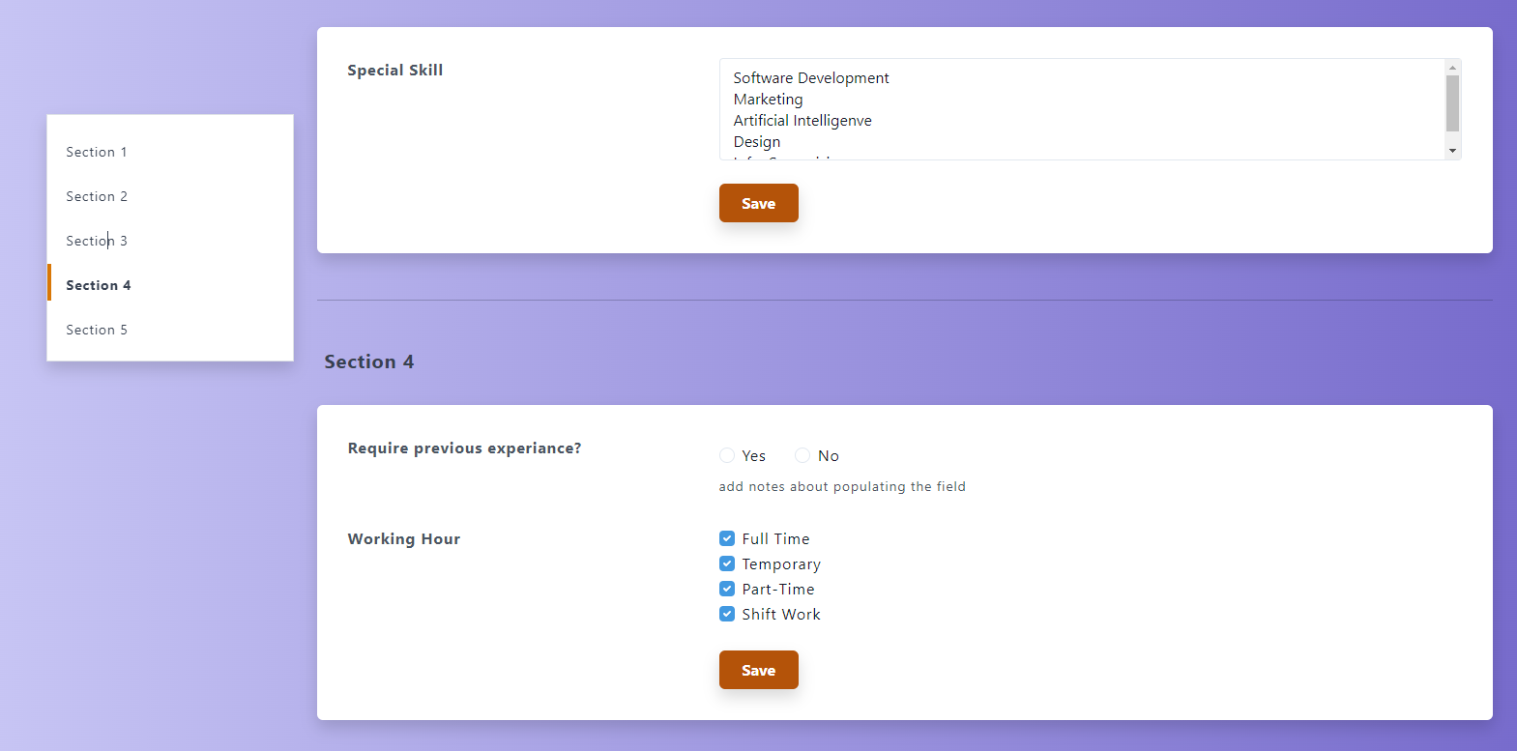

Section-05

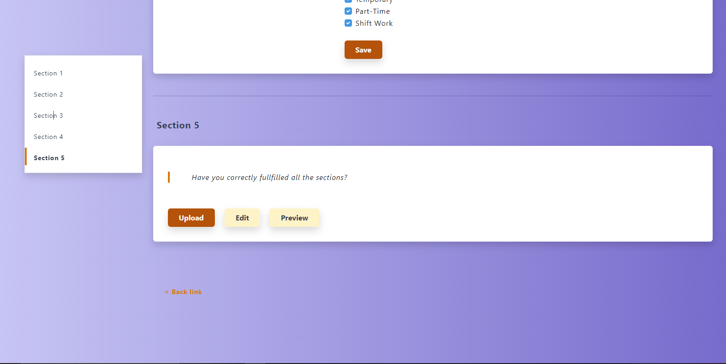

alumnIUB: <https://alumniub.netlify.app>